# In the fixtures folder we have “example.json” file

## Code:

{

“username” : “Admin”,

“password” : “admin123,

“invaliduser” : “ADMIN”,

“invalidpass”: “123”

}

# Integration folder > advanced folder > Create Logindatadriven.js

## Code:

describe(‘using data driven approach’, () => {

// define before hook –

before(() => {

// Code to connect with the external file - example.json

cy.fixture(‘example’).then((data) => {

// Initialize my data, I have to make it a global instance

globalThis.data = data;

})

});

it(“test1”, () => {

cy.visit(“https://opensource-demo.orangehrmlive.com/web/index.php/auth/login”)

// Using data variable to fetch the values of username and password from the //external json file

//cy.get(‘[name=”username”]’).type(‘Admin’)

cy.get(‘[name=”username”]’).type(data.username)

//cy.get(‘[placeholder=”Password”]’).type(‘admin123’)

cy.get(‘[placeholder=”Password”]’).type(data.password)

cy.get(‘.orangehrm-login-button’).click()

})

It(‘test2’, () => {

cy.visit(“https://opensource-demo.orangehrmlive.com/web/index.php/auth/login”)

cy.get(‘[name=”username”]’).type(data.invaliduser)

cy.get(‘[placeholder=”Password”]’).type(data.invalidpass)

cy.get(‘.orangehrm-login-button’).click();

});

});

# Installing cypress iframe

Command is [npm install -D cypress -iframe].

## In the Support folder > e2e.js file

Which has: require(‘cypress-xpath’);

require(‘cypress-iframe’);

# In the integration folder > Advanced folder > Create frametest.js

describe(‘tests’, () => {

it(‘test1’, () => {

cy.visit(‘https://rahulshettyacademy.com/AutomationPractice/’)

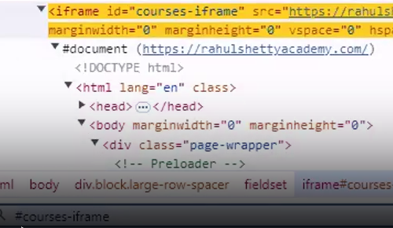

// we are loading the required i frame.

cy.frameLoaded(‘#courses-iframe’)

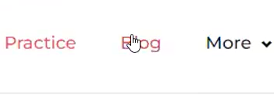

// Using iframe() I am checking for a blog element and then clicking on it

cy.iframe().contains(‘Blog’).click();

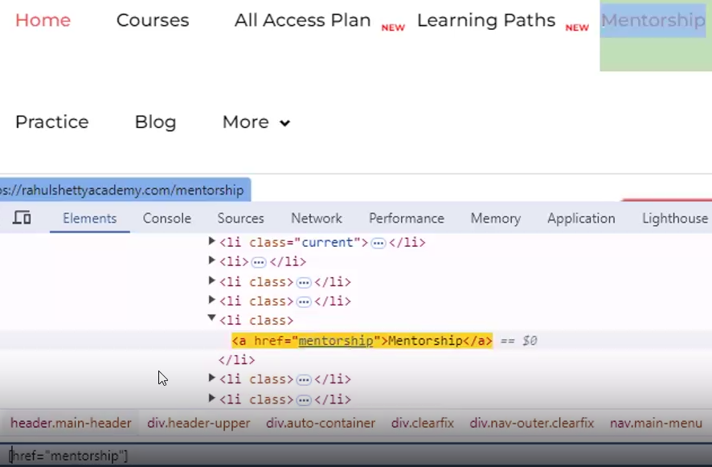

cy.iframe().find(‘a[href=”mentorship”]’).click()

});

It(‘frame2’, () => {

cy.visit(‘https://v1.training-support.net/selenium/iframes’)

cy.frameLoaded(‘iframe[src=”/selenium/frame1”]’)

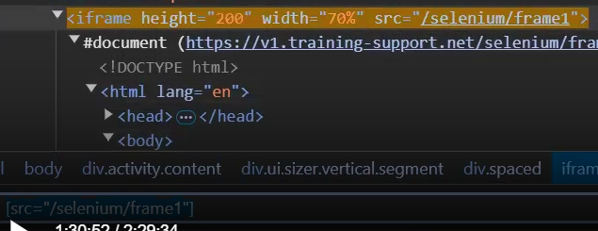

// using find() – providing locator and then click on the first matching element

cy.iframe().find(‘#actionButton’).first().click();

});

It(‘frame_2’, () => {

cy.visit(‘https://v1.training-support.net/selenium/iframes’)

cy.iframe(‘iframe[src=”/selenium/frame1”]’).find(‘#actionButton’).first().click();

});

})

# Create a new file uploading.js in the advanced folder in the integration folder

describe(‘upload’, () => {

it(‘test1’, () => {

cy.visit(‘https://the-internet.herokuapp.com/upload’)

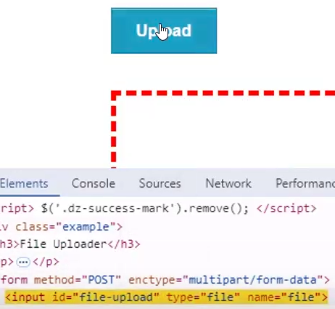

cy.get(‘#file-upload’).selectFile(‘c:/Users/Dell/Desktop/image.jfif’)

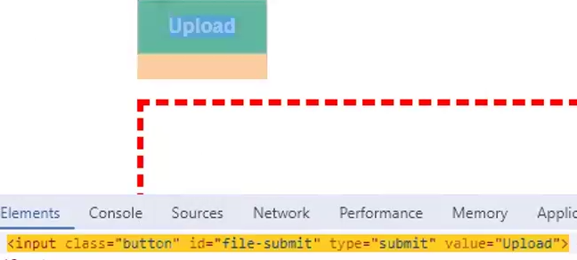

cy.get(‘#file-submit’).click()

});

});

# Create a scrolling.js file in the advanced folder

describe(‘scroll test’, () => {

it(‘test1’, () => {

cy.visit(‘https://www.google.com/’)

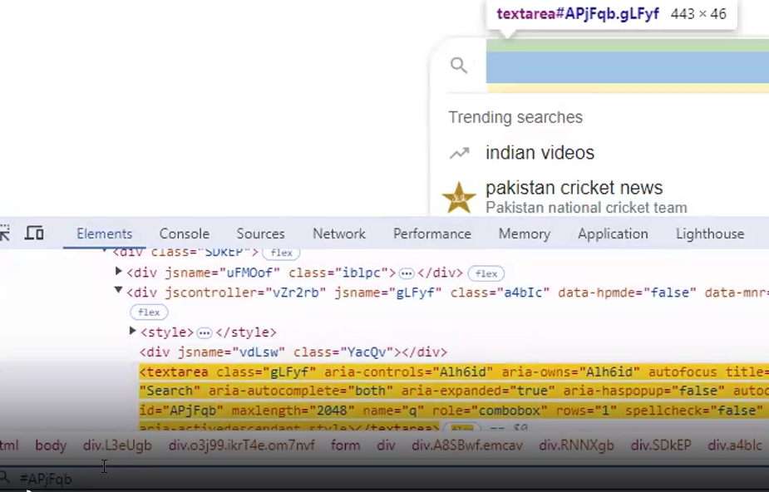

cy.get(‘#APjFqb’).type(‘Masai{enter}’);

// x – horizontal coordinate and y – vertical coordinate

// Scroll downwards

cy.scrollTo(0, 1000)

// Scroll upwards

cy.scrollTo(0, -1000)

// Scrolling into a particular element

cy.contains(‘Maasai people’).scrollIntoView().click();

});

});